User Guide 1 Creating an application in SPEAR
Purpose of this User Guide
The purpose of this guide is to provide information on how to prepare a subdivision or other survey-based application in SPEAR.
Who should read this guide?
Primary audience: Applicants
For information: Responsible Authorities and referral authorities
Introduction
Completing the SPEAR online application wizard to create a subdivision or a survey-based application is the first step in creating an electronic application.
SPEAR provides an electronic, online alternative to the paper application process. Instead of submitting application forms and supporting information, such as plans in paper form, they may be submitted by completing an electronic application in SPEAR and attaching electronic copies of supporting documentation in PDF format. The documents, such as plans, titles, reports and photos, are stored in SPEAR where they can be conveniently retrieved, viewed, and acted upon by the Responsible Authority, referral authorities (RAs) and applicants to process or monitor the progress of an application.
  - What types of applications can be created and lodged in SPEAR?
An Applicant Contact who is a registered SPEAR subscriber from an organisation employing a Licensed Surveyor can create applications under the various acts, including the Subdivision Act, the Transfer of Land Act, and the Local Government Act.
See our website for a full list of SPEAR Dealing Types and who is eligible to create and lodge them.
  - Can applications be submitted to the Surveyor-General Victoria in SPEAR?
Yes. See User Guide 55 – Submissions to Surveyor-General Victoria for more information.
  - What type of applications can NOT be lodged in SPEAR?
- Any application not described in section 1.1
- Plans of subdivision where the subject land falls in more than one local government area
- Plan of subdivision or consolidation from a member of the public that requires certification by the Responsible Authority.
  - How do you make a payment to the Responsible Authority for a SPEAR application?
Payments can be made within SPEAR, using a Visa or MasterCard. Not all Responsible Authorities accept online payments. Payment can still be made either by sending payment through the mail or in person at the Responsible Authority. Remember to provide the SPEAR reference number when making payment.
NOTE: A Responsible Authority may choose not to accept your application in SPEAR until the relevant fees have been received and cross referenced.
  - Can I lodge a VicSmart application in SPEAR?
Yes. You can indicate on the application form that the planning permit or joint application is a VicSmart application. Documents supporting the VicSmart application can be attached. The Responsible Authority will then assess the application and accept it as a VicSmart application or not.
  - How do I create a new subdivision application in SPEAR?
Login to SPEAR using your username and password. This will open the Applications List screen. Select ‘Create New Application’ from the list at the top right of the screen.
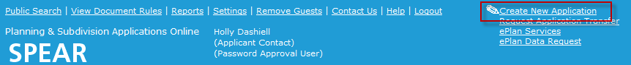

Step 1 - Application Details
Choose an ‘Application Type’ from the drop-down list and click ‘select’.
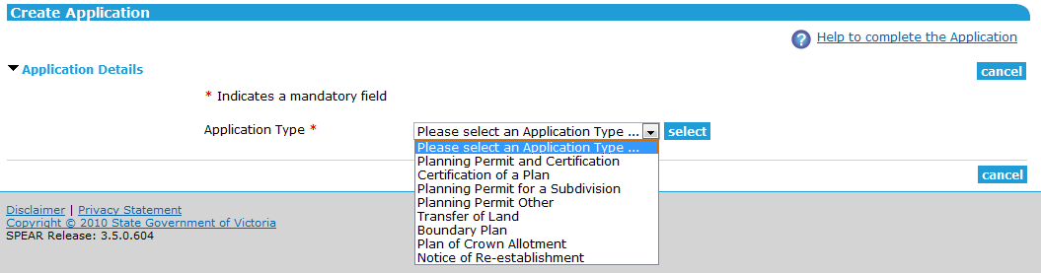
NOTE: The example portrayed in this User Guide is a joint application for planning permit and certification. The displayed fields may differ depending on your application type.

The subdivision application wizard will expand to reveal additional fields. You may add your reference number in the ‘Applicant Reference Number’ field and an application or Estate name in the ‘Application name or Estate name’ field.
If an ePlan has been prepared within the ePlan Portal, you will be able to use the Select ePlan link when the application type is a boundary plan or includes a certification component. This will allow you to upload your ePlan first and prepopulate most of the application wizard with data from your ePlan.

Step 2 -The Land
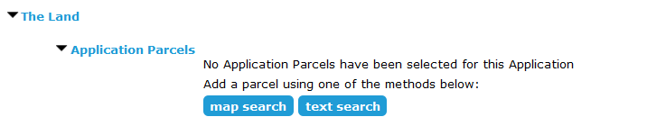
Select your preferred search method from ‘map search’ or ‘text search’.
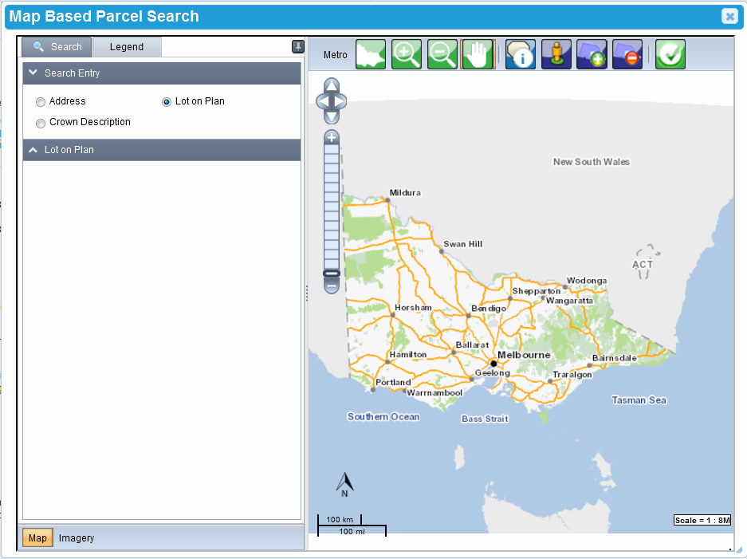
When selecting ‘map search’ a new pop-up window will appear ‘Map Based Parcel Search’. From ‘Search Entry’ you can search by address, lot on plan or crown description.


If multiple results are found, select the checkbox for the correct address then click . Once loaded click ‘Select Parcel’ and click on each relevant parcel.


NOTE: When selecting a base-parcel in a multi-level building, a list of individual parcels will appear on the left. Select the checkbox next to each required parcel.
Once you have selected the required parcel(s) click ‘Complete Selection’ .
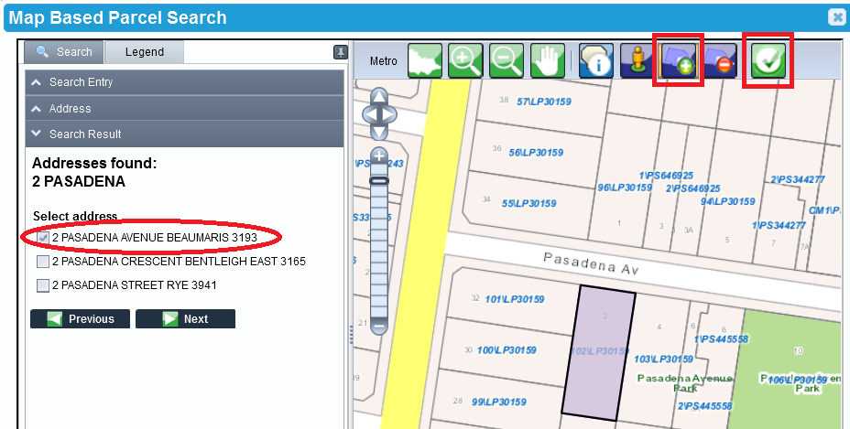
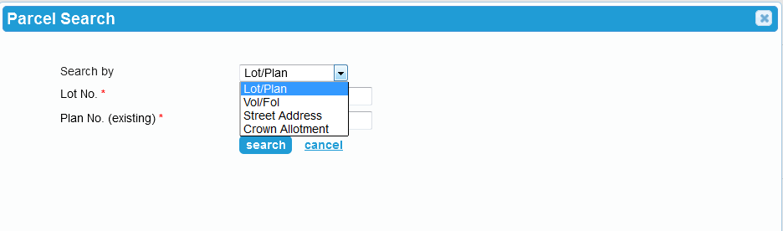
Alternatively, when selecting ‘text search’ a pop-up window will appear. Enter the required property details and click ‘search’. SPEAR will perform a database search to confirm the address.

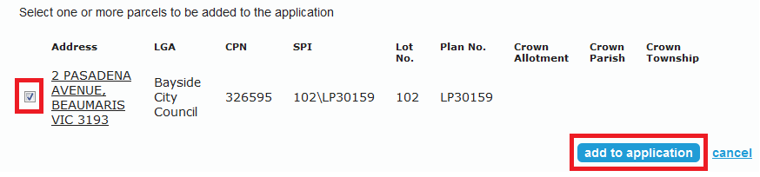
Once your application parcel(s) are returned from the database via either a text or map search, select the checkbox and click ‘Add to Application.’ You can perform additional searches and add multiple parcels to your application if required.

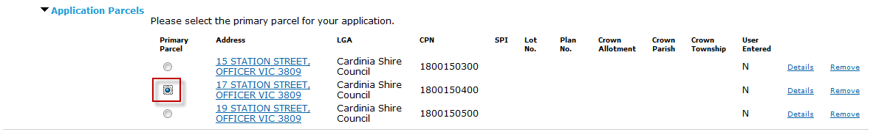
If you have added multiple parcels to an application, you will need to indicate which is to be the primary parcel.

Step 3 - The Proposal
Select which section of the Subdivision Act you are applying under, and the dealing type that describes your application using the drop-down lists provided.
HINT: If a section of the Subdivision Act is greyed out, you won’t be able to select it due to an incompatible application type selected in step 2.
You may also need to enter other information such as the:
- Plan number (and stage number, if applicable)
- Number of lots
- Indicate if the application meets VicSmart requirements
- Number of new Limited and Unlimited Owners Corporations being created
- Description of the proposal
- Estimated cost of the development
- Estate name
NOTE: You will also need to answer some additional questions relating to Owners Corporations if you are creating an application under Section 32 of the Subdivision Act.

HINT: Mandatory Fields are indicated with a red asterisk (*).
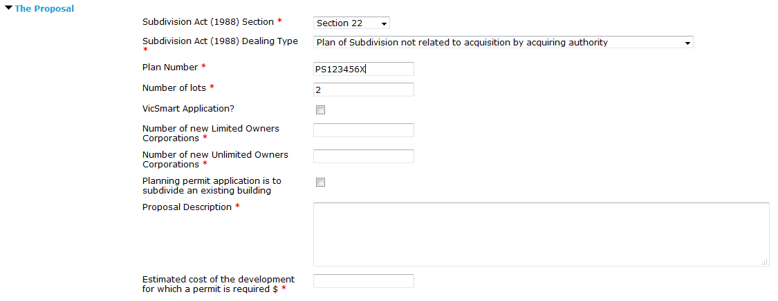

Step 4 -Existing Conditions
This section of the wizard requires you to describe, in general terms, the way the land is currently used, including any activities, buildings, structures and works that exist. You will also need to declare if there are any encumbrances on the title. An encumbrance is a formal obligation on the land, such as a restrictive covenant, Section 173 agreement, easement, or building envelopes.
Enter information regarding how the land is currently used and select the relevant option under the heading ‘Title Information - Encumbrances on Title’.
An explanation on the options available under the heading ‘Title Information - Encumbrances on title’ is as follows:
- ‘Yes’ means there is an encumbrance, and the application is in breach
- ‘No’ means there is an encumbrance, and the application is not in breach
- ‘Not applicable’ means there is no encumbrance.
Selecting ‘Yes’ requires additional comments to be entered and will trigger a mandatory action for the Applicant Contact to ‘Add Covenant Document’. It is suggested that you contact the relevant Responsible Authority for advice on how to proceed with the application.
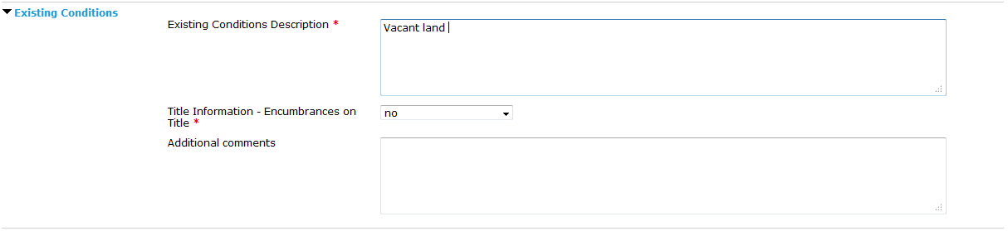
Selecting ‘No’ or ‘Not applicable’ does not require additional comments to be entered and allows for an optional action to ‘Add Covenant Document’ if required at a later stage during the life of the application.

Step 5 - Applicant & Owner
There are three components to this section, the Applicant Contact, applicant and owner, each of which must be dealt with separately.
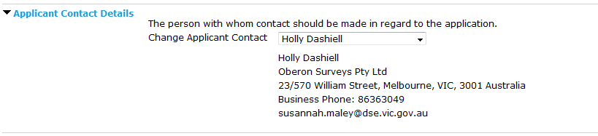
The Applicant Contact is the SPEAR user who is making the application. The contact information is populated here from the logged in user's profile. If required, you can select an alternative contact person from within your organisation via the drop-down list.

The applicant is the person or organisation that requires the certification of the plan and/or planning permit. The applicant can be the Applicant Contact or a client. If the Applicant Contact and the applicant are the same person, then check the box ‘Applicant is the same as the Applicant Contact’. Otherwise click ‘Add Applicant’. A pop-up window will appear, enter the appropriate information in the fields provided and click ‘add to application’. More than one applicant can be assigned to an application by clicking ‘add another applicant’.

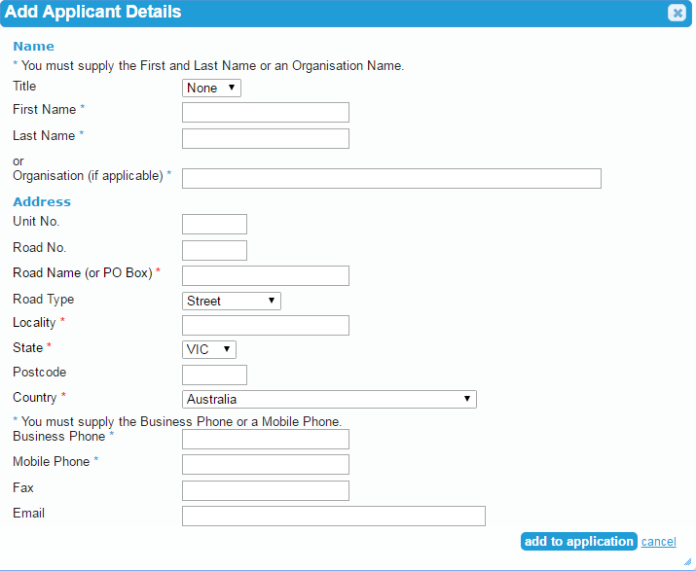
The owner is the person or organisation that owns the land at the time the application is made. The owner can be the applicant and/or the Applicant Contact, or anyone else. There are two check boxes that can be selected ‘Owner is the same as the Applicant Contact’ or ‘Owner is the same as the Applicant’. However, if the owner is neither click ‘Add Owner’. A pop-up window will appear, enter the appropriate information in the fields provided and click ‘Add to Application’.
NOTE 1: The owner may not be required for some application types.
NOTE 2: More than one owner can be listed against a property application by filling in their details and clicking ‘add to application’ for each owner. If the second owner lives at the same address (e.g. a husband and wife) the address will appear in the ‘Select Address’ drop-down box.
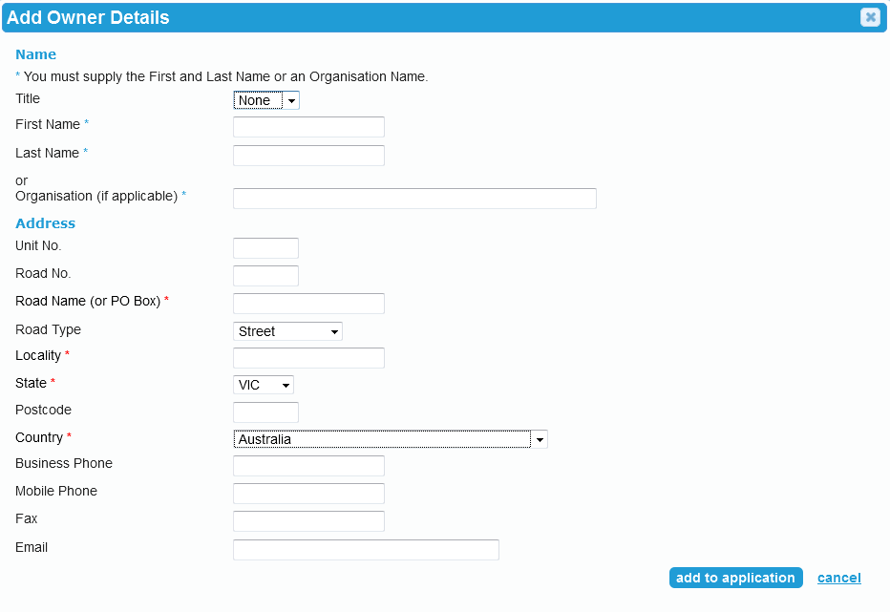

Click ‘save & close’ when you are ready to move on to the next phase of creating your application.
NOTE: You can click ‘save’ at any time and return later to complete the application.

Step 6 -Mandatory Actions
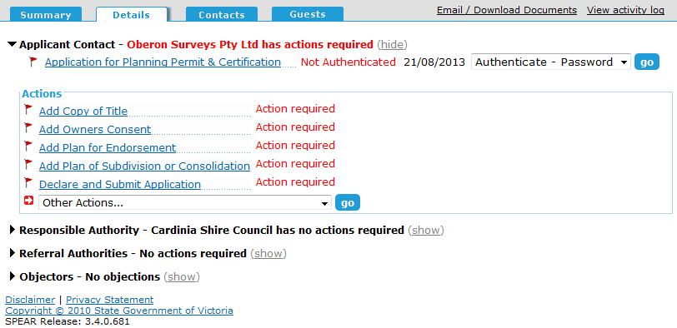
You will now be prompted to carry out several mandatory actions before the application can be submitted to the Responsible Authority through SPEAR.

Mandatory actions include attaching plans, copy of title(s), owner's consent etc. The documents that SPEAR prompts you to add through mandatory actions will be dependent upon the type of application you are about to submit to the Responsible Authority.
Optional actions are available by using the ‘Other Actions…’ drop-down list. Optional actions allow you to add additional supporting documentation, such as a covering letter, reports, or photos. If you cannot find an optional action to suit your needs, you can select ’Add Other Document Type’ for anything that falls outside the selection available.
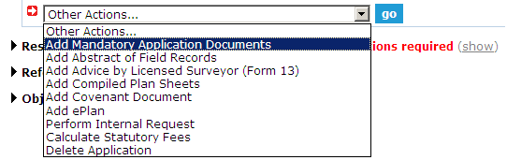
SPEAR provides a facility to upload the mandatory documents in one step by selecting ‘Add Mandatory Application Documents’ from the ‘Other Actions…’ drop-down list.

NOTE: To finalise your TLA survey-based application or boundary plan for submission to Land Use Victoria you should complete the mandatory action to ‘Release for Lodgment’. For further information see User Guide 9 – Releasing documents for lodgment at Land Use Victoria.
You can find further information about attaching documents in User Guide 42 - Authentication – User Levels & Documents, and User Guide 43 - Key SPEAR Screens.

Step 7 - Declare and Submit Application
Once you have added all the mandatory application documents, you will need to click the final mandatory action, ‘Declare and Submit Application.’
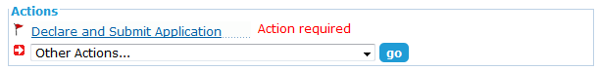

If the Responsible Authority accepts payments through SPEAR, you will need to indicate whether you will pay the fee online now or submit the application without paying the fee. If you wish to submit without paying the fee, you can pay outside of SPEAR, pay later via SPEAR, or invite a guest to pay in SPEAR.
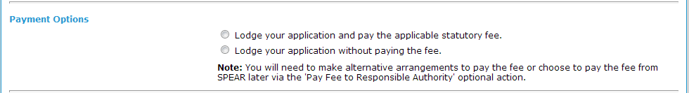

As the Applicant Contact, you are required to make a declaration in relation to the information and documents you have provided. Once you have read through the information on the page, click the appropriate check boxes to make your declaration and click ‘Submit Application’.
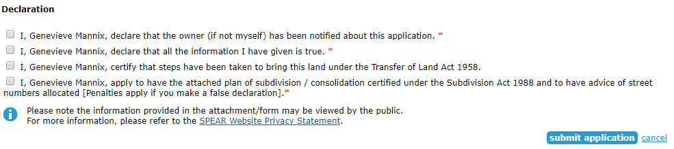

The Details screen is now displayed, and your application status is now ‘Submitted’.

  - Can I modify my application in SPEAR?
Most details can be modified on an application while it is in ‘Draft’, (notable exceptions are application type and the Responsible Authority which cannot be altered). After the application has been submitted to the Responsible Authority, amendments can be made to the application and are regarded as changes to the application form, (example, changing the property address, permit category, owner’s details, etc.).
An amended application document must go through a new step, ’Submit All Proposed Changes to Responsible Authority’. Amendments must be accepted by the Responsible Authority for them to be considered as part of the current application. Until these amendments are accepted, amended documents appear on the Details tab view as ‘Proposed’ changes. Any changes made to the online application form will require Step 5 - Declaration to be completed again. On the Details tab click on 'go' next to 'modify' in the drop-down box next to the Application for Planning Permit & Certification link to make any required changes.

New versions of documents or additional documents can be added to SPEAR at most stages of the application process. Some documents are considered to constitute an amendment to the application. These documents must be submitted to the Responsible Authority as proposed changes.
The Responsible Authority may reject an application submitted through SPEAR. SPEAR prompts the Responsible Authority to attach a letter of explanation for the rejection. The application then reverts to ‘Draft’ which allows you to modify the application for re-submission to the Responsible Authority if necessary.
  - How does SPEAR link a separate planning permit application with a new SPEAR application for certification?
When creating a new certification application, you can link the new application to a previously issued or requested SPEAR planning permit by providing the SPEAR reference number of the planning permit application. You can link multiple certifications to the one joint or planning permit application.
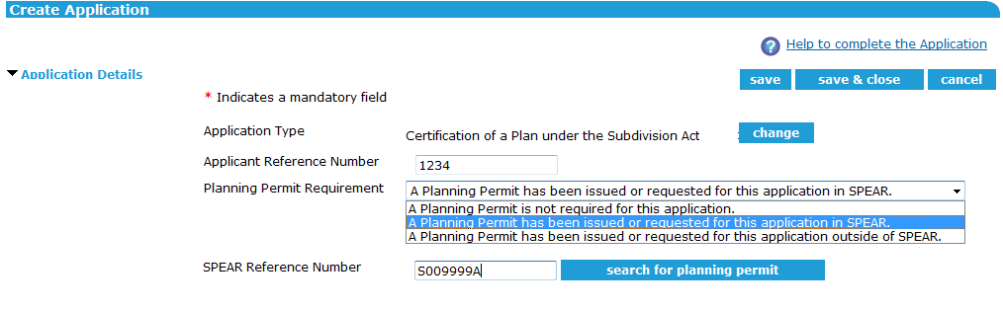
When linking two or more SPEAR applications, SPEAR will automatically populate key details and documents (if available) from the planning permit application into the new certification application. However, the Applicant Contact is still responsible for ensuring that the new application details and any attached documents are accurate and appropriate.

  - Who can see my draft application?
By clicking ‘save’ or ‘save and close’, your application will be saved as a draft application. Only users within your organisation will be able to view a draft application before it has been submitted to the Responsible Authority.
Once the action ‘Declare and Submit Application’ has been completed, the status of the application changes to ’Submitted’ and the Responsible Authority can view your application. You will not be able to delete any of the application documents from this point.
  - If I decide to withdraw my SPEAR application, what do I need to do?
If a SPEAR application is at ‘Draft’, the Applicant Contact can delete the application by selecting the ‘Delete application’ action from the ‘Other Actions…’ drop-down list.
If you no longer wish to proceed with an application that has been submitted to the Responsible Authority and a Responsible Authority decision has not yet been reached, it must be withdrawn. The ‘Withdraw application’ action is available to an Applicant Contact via the ‘Other Actions…’ drop-down list. Plan numbers of applications that have been withdrawn from SPEAR can be re-used in another SPEAR application.
If the Applicant Contact wishes to reinstate a withdrawn application, they must contact the Responsible Authority. The Responsible Authority can reinstate an application by selecting ‘Restore Withdrawn Application’ from the ‘Other Actions…’ drop-down list.

Need more information?
Further information on this topic can be found by:
- Visiting the SPEAR website: www.spear.land.vic.gov.au
- Contacting the SPEAR Service Desk on 9194 0612 or email spear.info@delwp.vic.gov.au
- Selecting the Help link in the relevant area of the SPEAR system.
- Referring to:
- Tech Note 4 – Applicant Contact Created Documents in SPEAR
- User Guide 9 – Releasing documents for lodgment at Land Use Victoria
- User Guide 42 – Authentication – User Levels & Documents
- User Guide 43 – Key SPEAR Screens.

